Drivers of Change in Soil Organic Matter Stocks - Loss & Gains

Kristy Lam

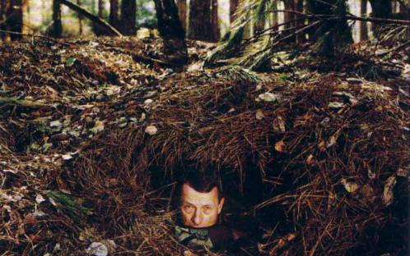

Late soil ecologist Jenny Hans under Spodosol leaf litter from [University of Maryland](https://extension.umd.edu/learn/soil-organic-matter)

# Understanding SOM

In order to understand SOM, one needs to move away from the traditional “humification” model and instead think of SOM as a continuum of progressively decomposing organic compounds as well as microbial-synthesized substances (see JW-1). OM does not persist because of its intrinsic properties, rather it is the physicochemical and biological influences from the surrounding environment that reduce the probability and rate of decomposition. Thus, long-term, in situ studies of entire soil profiles are necessary to investigate distinct mechanisms underpinning soil carbon sequestration. Schmidt et al. (2011) studied the persistence of SOM as an ecosystem property and recommended potential improvements for representing C in ecosystem models (Table 1).

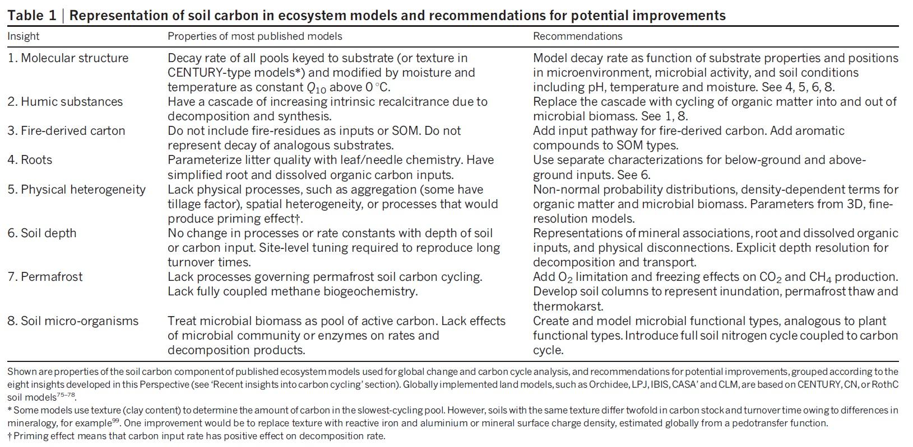

Table 1 from Schmidt et al. (2011) DOI: [10.1038/nature10386](https://www-nature-com.eres.library.manoa.hawaii.edu/articles/nature10386)

Source:  
Lehmann and Kleber (2015) DOI: [10.1038/nature16069](http://www.nature.com/doifinder/10.1038/nature16069)  
Hubanks et al. - in press  
Schmidt et al. (2011) DOI: [10.1038/nature10386](https://www-nature-com.eres.library.manoa.hawaii.edu/articles/nature10386)

# SOM dynamics - drivers of change

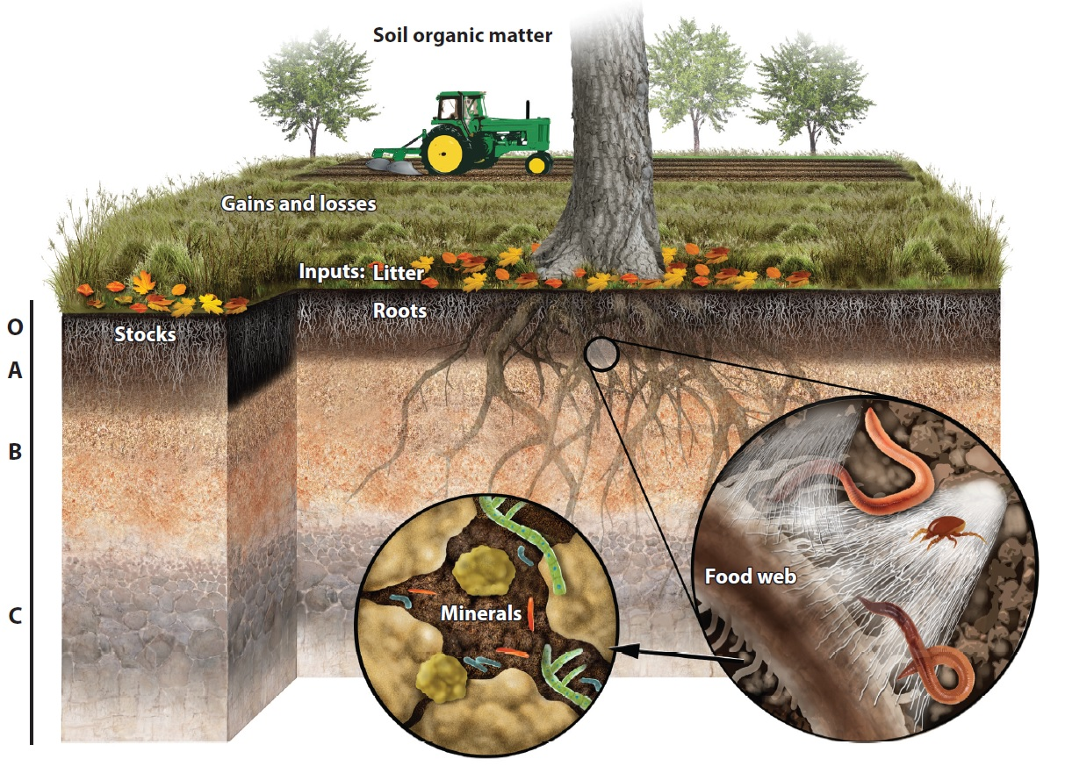

Figure 1. SOM factors from Jackson et al. (2017) DOI: [10.1146/annurev-ecolsys-112414-054234](https://www.annualreviews.org/doi/abs/10.1146/annurev-ecolsys-112414-054234)

In an ecosystem, soil C stock approaches its carrying capacity (Figure 2).

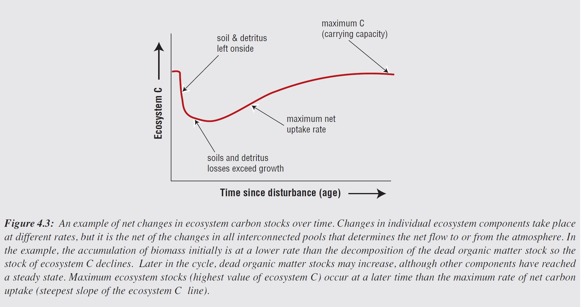

Figure 4.3. Net changes in ecosystem C stock over time from [IPCC](pdf)

Over time and space, SOM content can change via natural (biotic and abiotic) or anthropogenic influences. Many factors, such as hydrology, can result in both SOM loss or gain via erosion or deposition, respectively. Figure 1 lists several key factors contributing to SOM dynamics. This list is not exhaustive; more studies need to be conducted to properly understand the mechanisms driving SOM dynamics. Table 2 includes case studies for specific

Figure 3. Factors that drive SOM dynamics. Table 2. Corresponding papers

Over time and space, SOM content in any given soil can change via natural (biotic and abiotic) or anthropogenic influences. In native or undisturbed systems, soils can build SOM through inputs such as plant biomass aboveground and belowground (link to HaHu-1), microbial products and necromass (link to KH-2 & JP-2), ? and much more. However, SOM can be lost via microbial decomposition and erosion. Additionally, abiotic factors that can either accelerate or hinder OM decomposition include temperature/climate, soil drainage, soil texture, soil mineralogy, and topography. In agricultural systems, farmers often add OM amendments to their crops while activities such as grazing and tillage usually result in a loss of SOM.

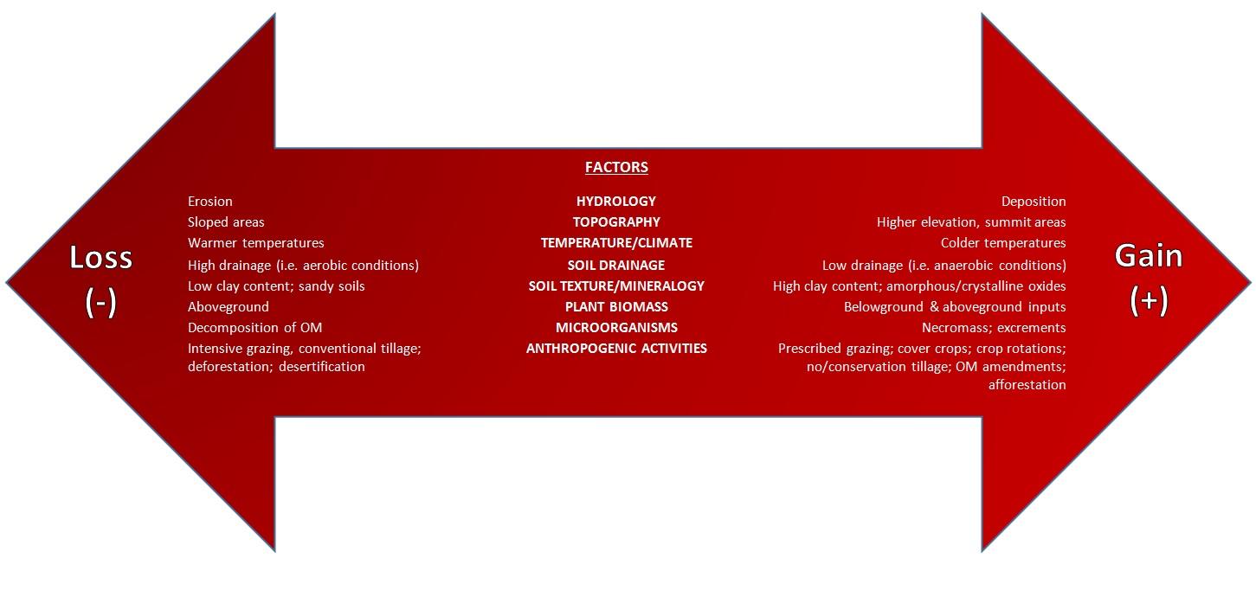

Figure 2. Gains and loss in SOM

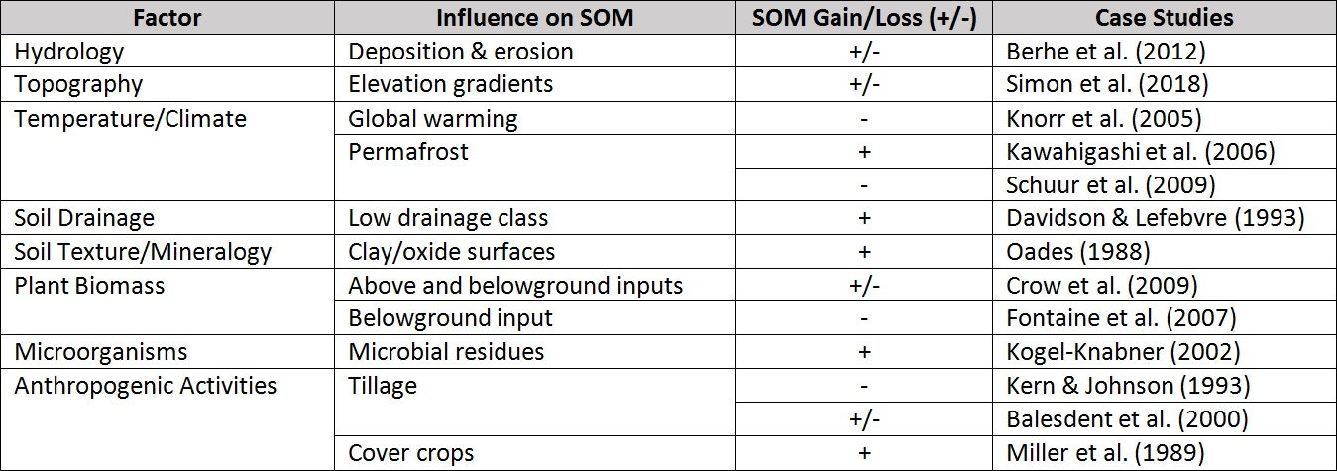

Table 2. Case studies of factors influencing SOM dynamics

Schmidt et al. (2011) DOI: [10.1038/nature10386](https://www-nature-com.eres.library.manoa.hawaii.edu/articles/nature10386)]  
Wills et al. (2013) DOI: [10.2136/sssaj2012.0168](https://www.soils.org/publications/sssaj/abstracts/77/5/1711)]  
USDA “Grazing Management and Soil Health” (2016) from NRCS  
“Climate Change 2001: Mitigation” Report from IPCC

# Current Initiatives

**Global Soil Organic Carbon (GSOC) Map**

The Global Soil Information System (GLOSIS), created by the Food and Agriculture Organization (FAO), has also developed a map showing C stock around the world - see map [here](http://54.229.242.119/apps/GSOCmap.html).

**Coordination of International Research Cooperation on soil Carbon Sequestration in Agriculture (CIRCASA) Project** CIRCASA is a European Union (EU) group that aims to develop international synergies concerning research and knowledge exchange in the field of carbon sequestration in agricultural soils at both EU and global levels.  
Visit this [website](https://www.circasa-project.eu/About-us)

**The Transboundary Agro-ecosystem Management Project for the Kagera River Basin (Kagera TAMP)** In Africa, efforts are being made to adopt an integrated ecosystems approach for the management of land resources in the Kagera Basin generate local, national, and global benefits. Watch this [video](https://www.youtube.com/watch?v=_c2tZ6mznvI).